# Hello World RESTful Web Service

# Project Structure –

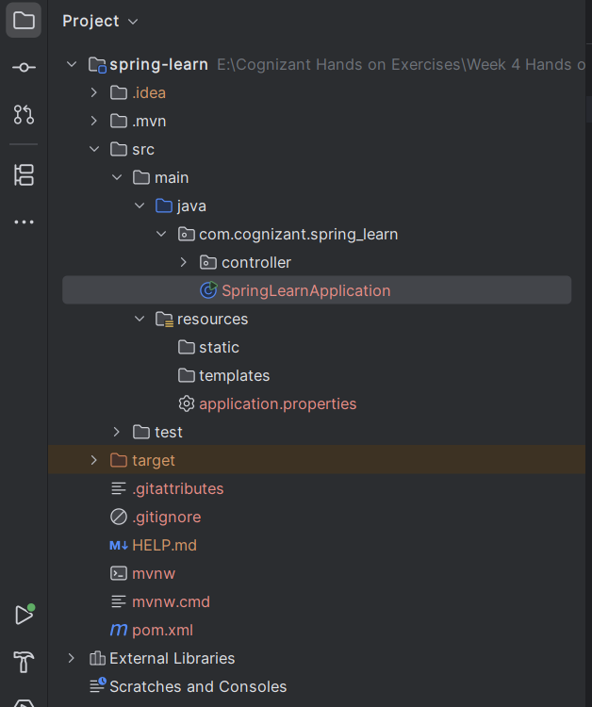

# Application Properties –

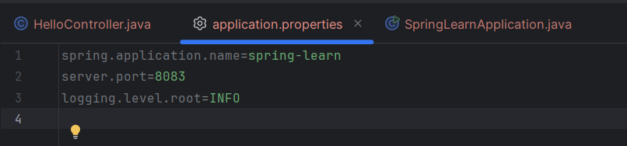

# Output while running the main class –

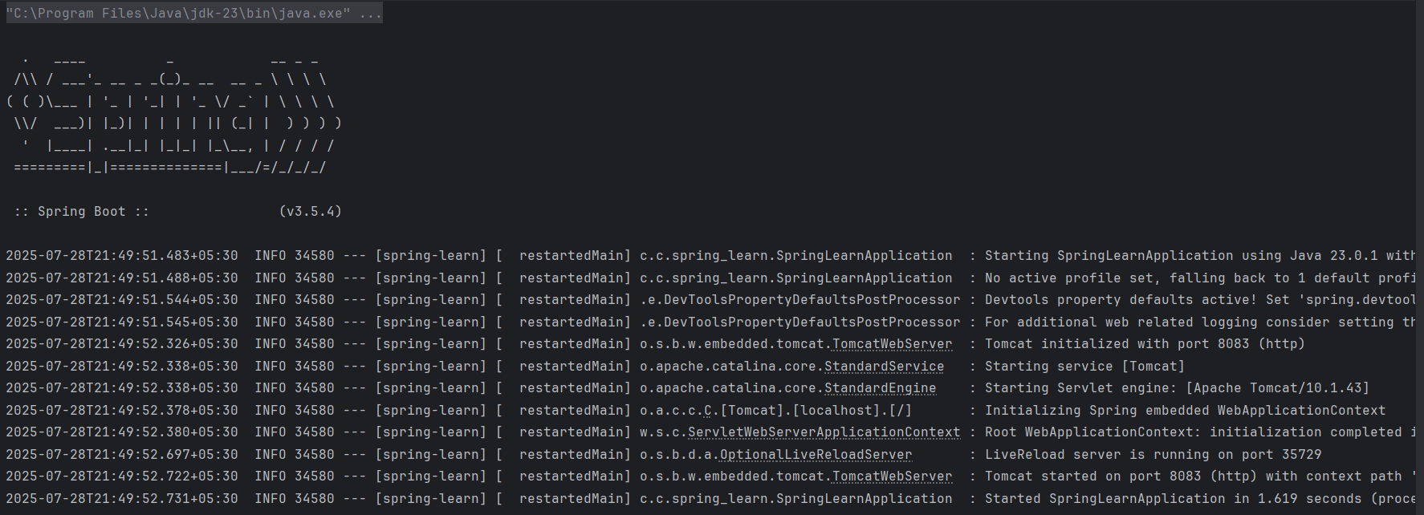

# Output on the port – http://localhost:8083/hello

